TITLE OF PAPER (max 100 characters; Calibri, 14pt bold)

Authors’ name (full names; Calibri 11pt bold, with presenting author underlined) e.g.,
Nicolas Kalogerakis¹, Eleni Manousaki¹, Philippe Corvini², Giulio Zanaroli³ and Fabio Fava³
Affiliations (Calibri 10pt ) e.g.,
¹ School of Environmental Engineering, Technical University of Crete, Greece
² Life Sciences School, University of Applied Sciences Northwestern Switzerland, Switzerland
³ Dept. of Civil, Chemical, Environmental and Materials Engineering – DICAM, University of Bologna, Italy

Corresponding author email: nicolas.kalogerakis@enveng.tuc.gr

ABSTRACT (Calibri, 12pt bold)
This page is the executive summary of your presentation. It should not exceed ONE PAGE (size A4 with 2.2 cm top, left, right and 1.8 cm bottom margins) and it should include the background of the work and its objectives, the methods/techniques used, the main results obtained, and the conclusions drawn.
Suggested subheadings:
Background information
Main results
Conclusions
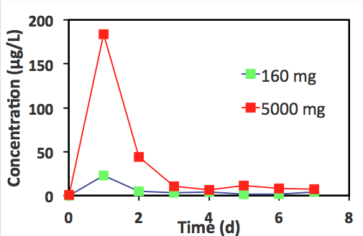
Please pay attention not to elaborate too much on the background. Background should be less than ¼ of the summary. The text of the executive summary should be written in single space, Calibri 11pt. You should leave 6pt between paragraphs with no indentation.
You may include one or more diagrams, if so desired – respecting the two-page limit.
You may include a few important references if desired and acknowledgement to funding sources.

Acknowledgements: The financial support by H2020 project XXXXXX contract No. YYYYYY is greatly appreciated.
References:
(References should be written in single space and in alphabetical order, font Calibri 10pt)
Syranidou, E., S. Christofilopoulos, M. Politi, N. Weyens, D. Venieri, J. Vangronsveld and N. Kalogerakis “Bisphenol-A removal by the halophyte Juncus acutus in a phytoremediation pilot: Characterization and potential role of the endophytic community”, J. Hazard. Mater., 323: 350–358 (2017).

***** Abstract should not exceed TWO pages *****

